**Code 1:**

(Had to write an iterative version of the code to check if my output was correct because the second prompt of the recursive algorithm wouldn’t execute even after raising the recursion limit up to ~50000, so my output is from the iterative code!)

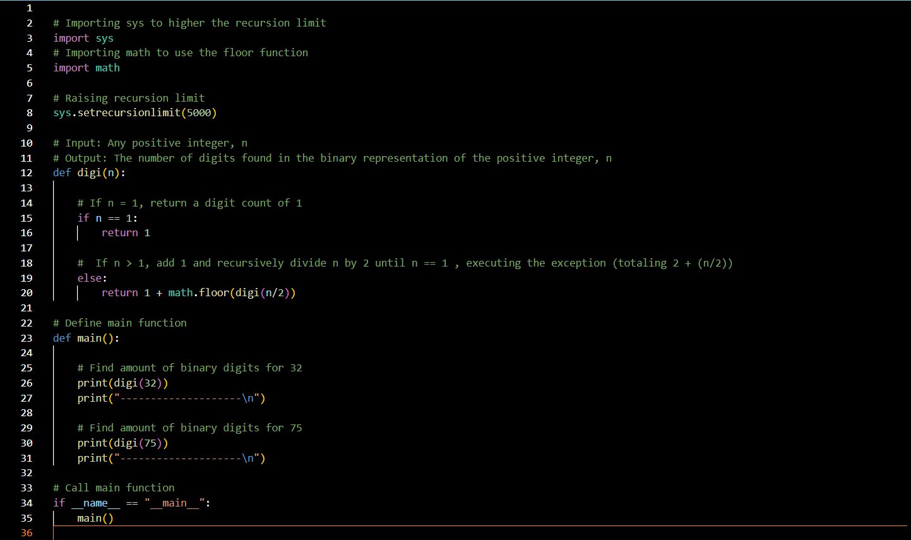

**Output 1:**

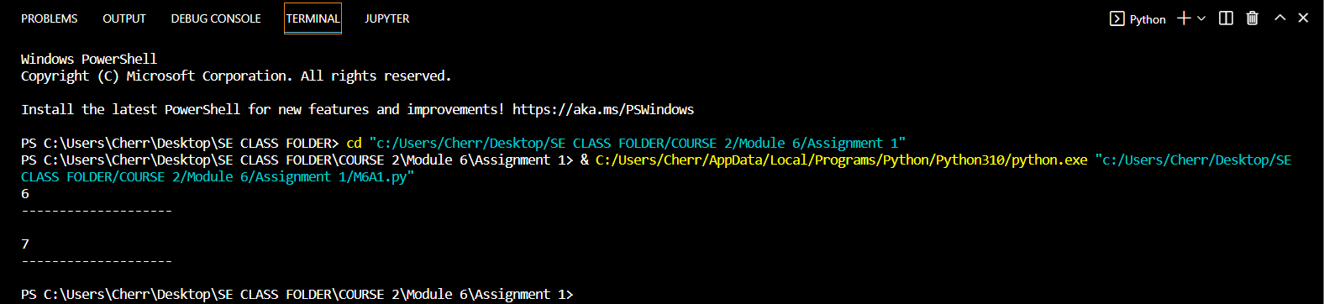

**Asymptotic Analysis for 1:**

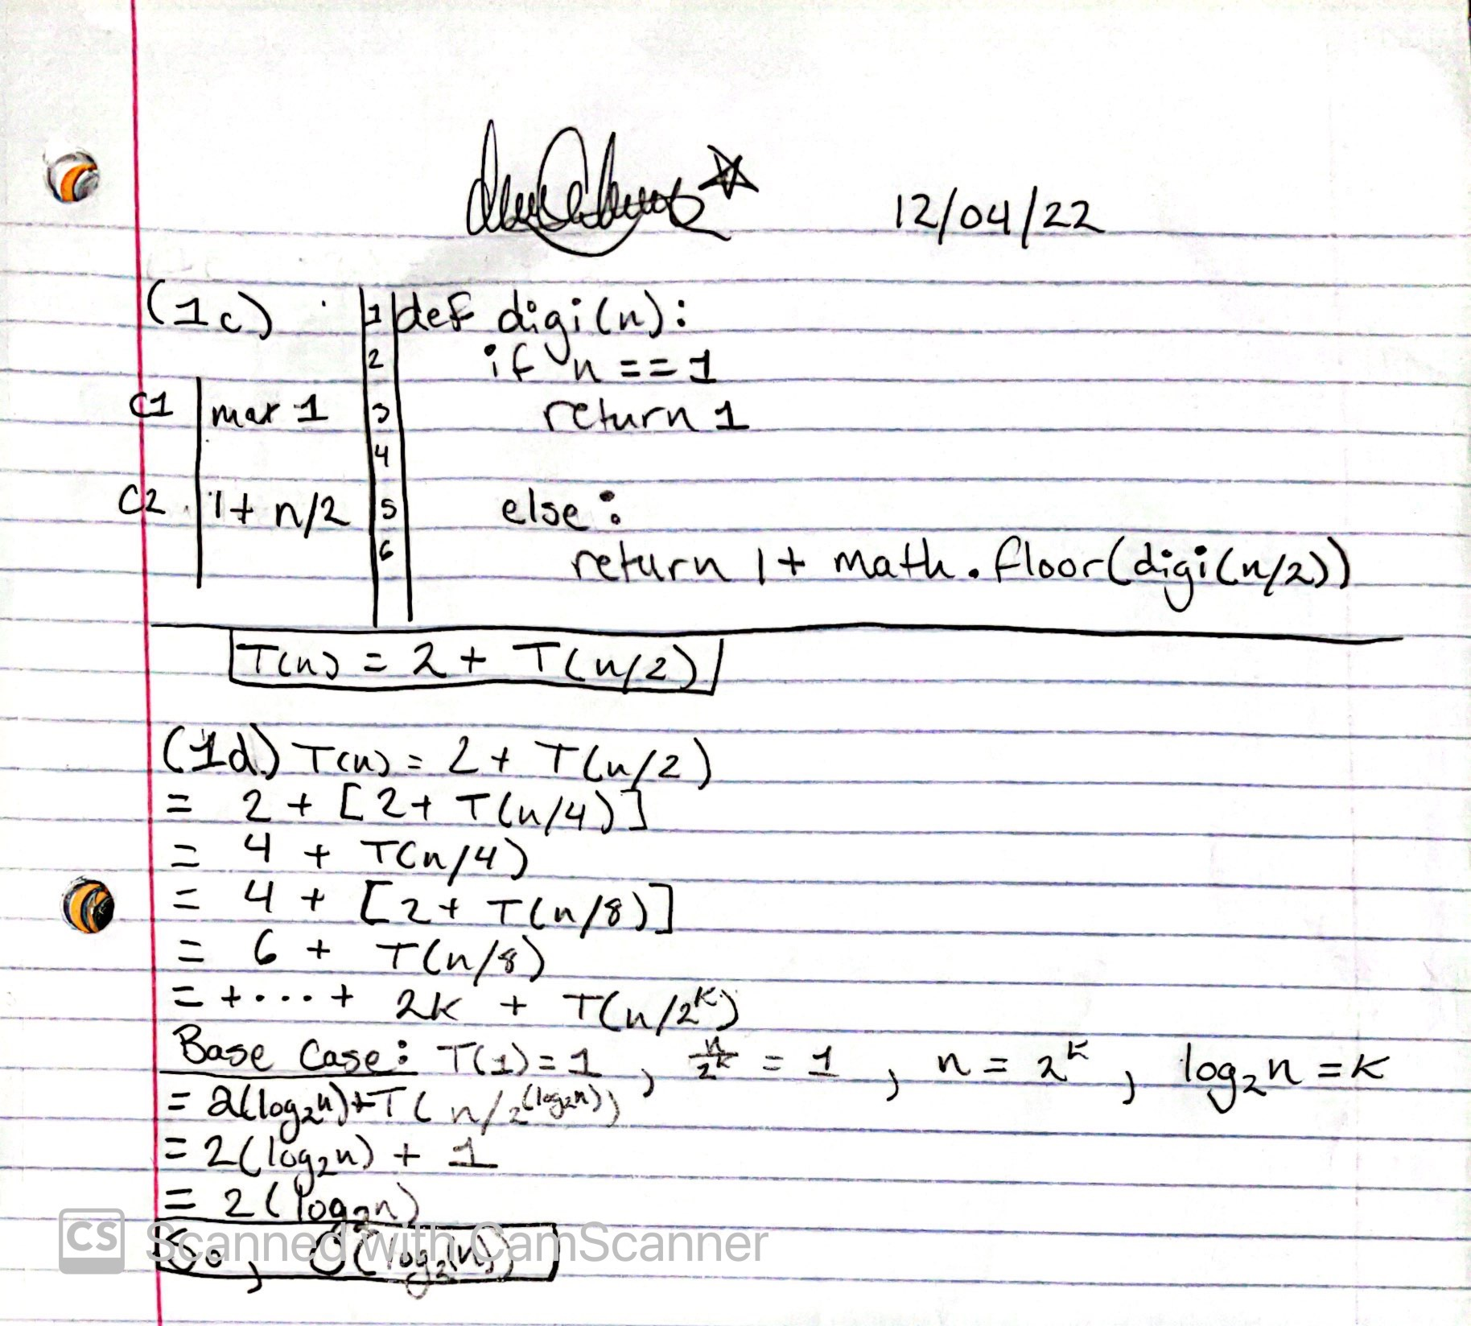

**Code 2:**

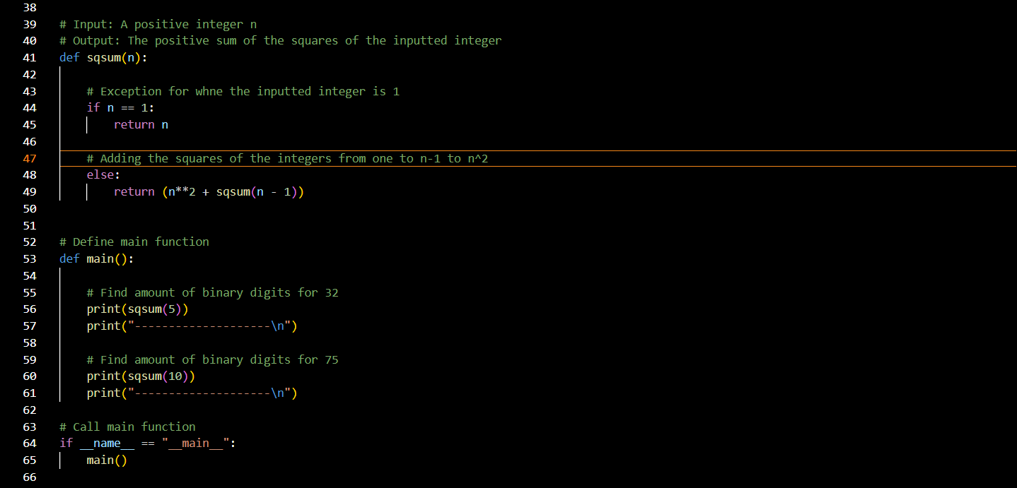

**Output 2:**

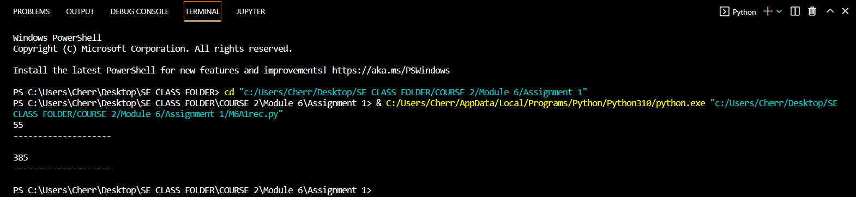

**Asymptotic Analysis for 2:**

